SMART PUMP CONTROL SYSTEM USING LORA COMMUNICATION AND MOBILE APP

This project is developed to control motor which is installed in fields far from home using Lora communication.

Working:

Firstly, it controlled via mobile app. There are some buttons on/off present in mobile app when button is on it transmit signal to controller and further controller did Radio frequency 865mz to send and receive signal to on/off the pump. At receiver end it decode the message and through controller at receiver side perform high/low.

Hardware used:

1. Two Lora modules Sx1278
2. Two microcontrollers at tx and rx end
3. Power adapters
4. Digital relays

TX part:

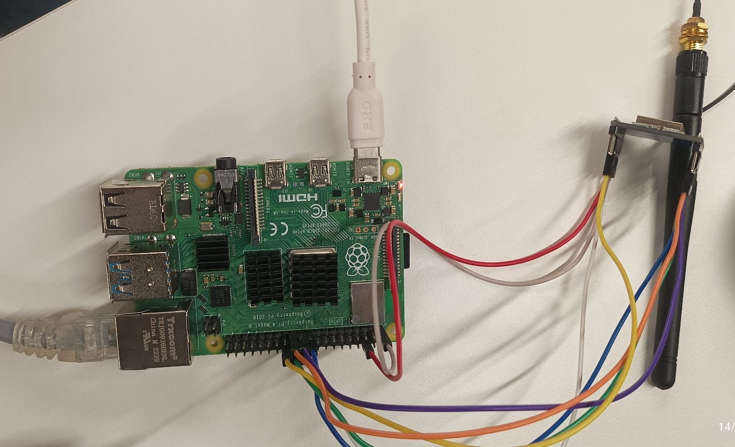

Rx part:

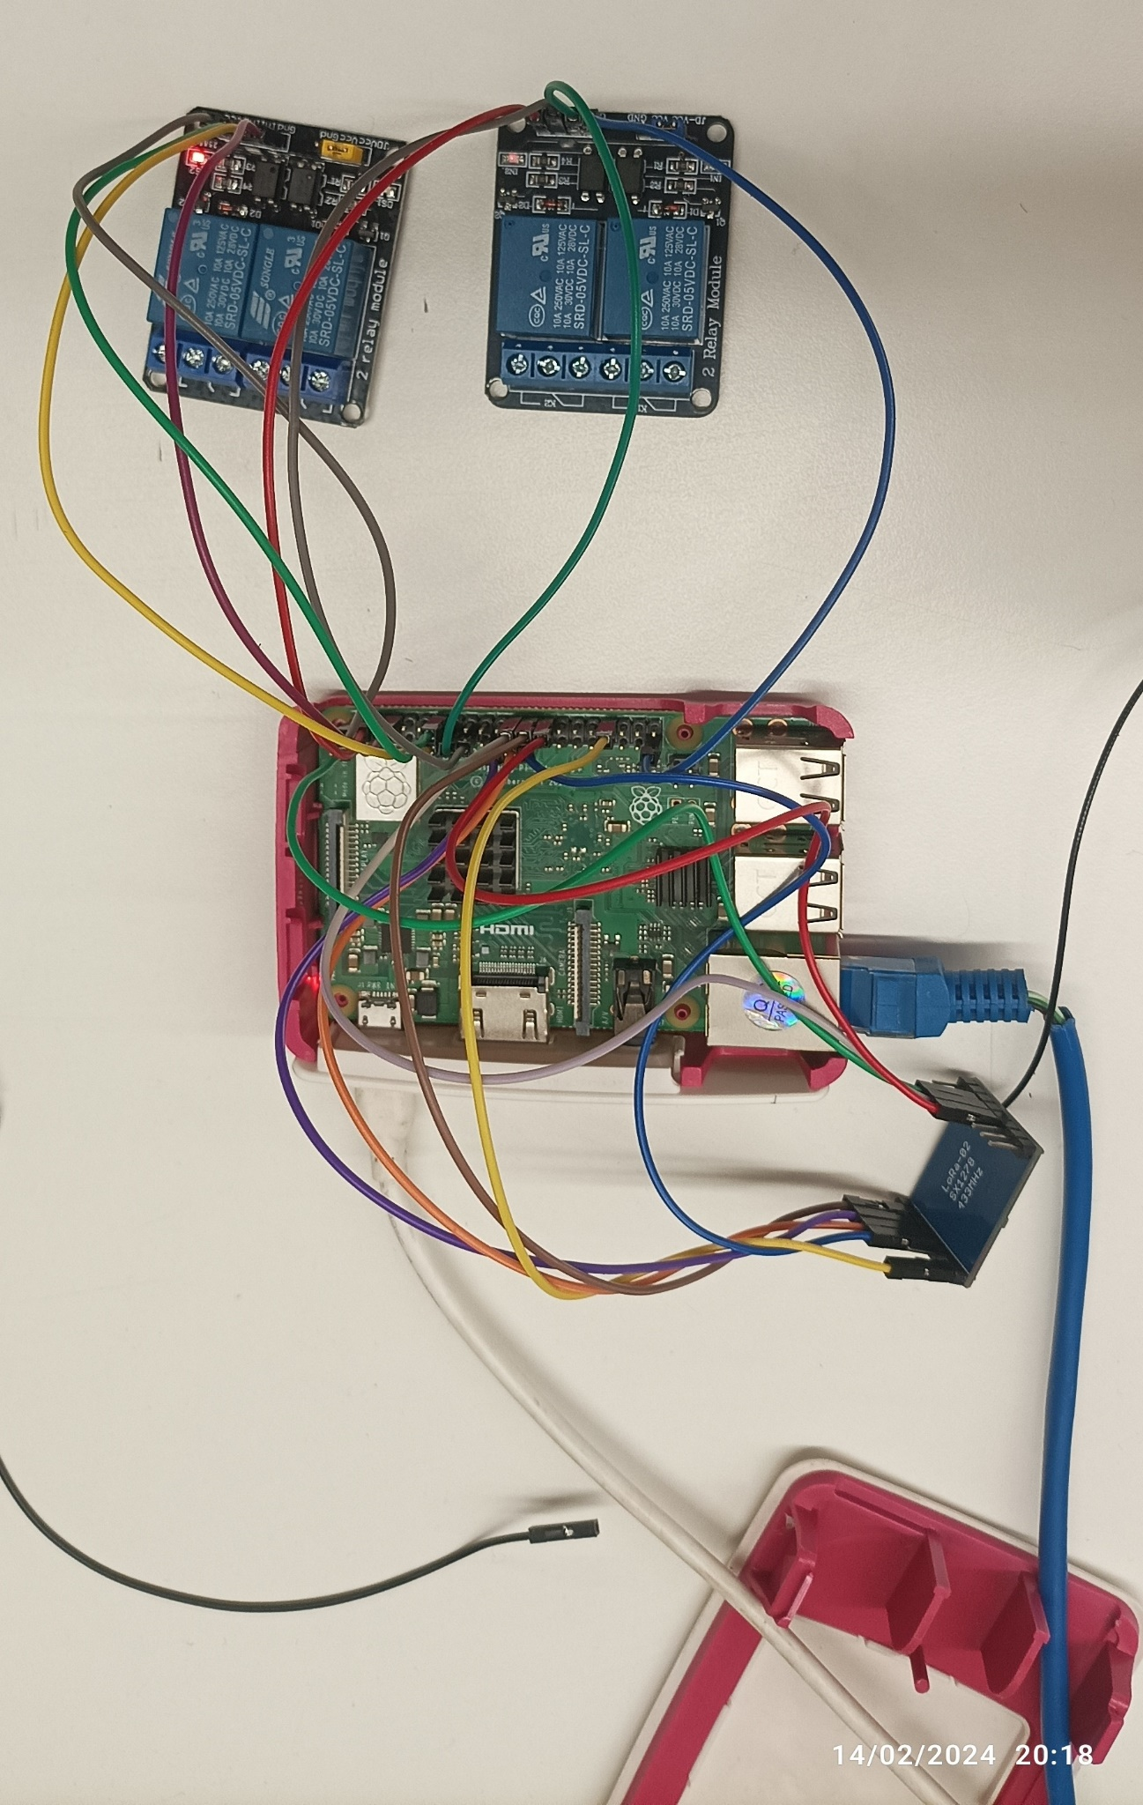

Advantages:

1. Energy saving
2. Water saving
3. Time saving
4. Remote control from any where
5. Cost effective
6. Resource saving

Application:

1. Further used for Smart Agriculture management system
2. Smart Agriculture Monitoring system
3. Smart Energy monitoring system